[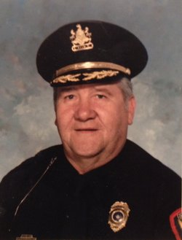](https://www.findagrave.com/memorial/177960680/robert-albert-stowman)

Photo added by [Doug Johnson](https://www.findagrave.com/user/profile/48480056)

[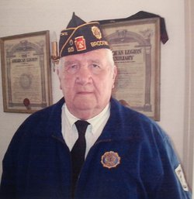](https://www.findagrave.com/memorial/177960680/robert-albert-stowman)Added by [Doug Johnson](https://www.findagrave.com/user/profile/48480056) [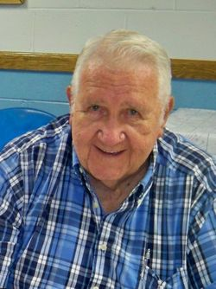](https://www.findagrave.com/memorial/177960680/robert-albert-stowman)

**Robert Albert Stowman Sr.**

|  |  |
| --- | --- |
| **Birth** | 5 Sep 1926  Philadelphia, Philadelphia County, Pennsylvania, USA |
| **Death** | 31 Mar 2017 (aged 90)  Brockway, Jefferson County, Pennsylvania, USA |
| **Burial** | Cremated, Ashes given to family or friend |
| **Memorial ID** | 177960680 · |

Robert Stowman was born in Philadelphia on September 5, 1926, the second child of Raymond and Elizabeth Peterson Stowman. His father was a streetcar motorman and his mother was a homemaker. The family history traces back to ones who came to this country on the Mayflower.  
Bob's brother Raymond was 2 years older, served in the U.S. Army during World War II and died at the age of 50. His brother Howard was 5 years younger, served in the U.S. Navy right after World War II and died at the age of 49. Both brothers died of heart attacks. His sister Beatrice was 7 years younger, and is married and lives in New Jersey now.  
Bob attended the Feltonville Elementary School in Philadelphia and moved along to the "Clara Barton and Mastbaum Vocational School" for high school. He was the only boy in his class to take Home Economics but joined the military before graduation. He returned later to obtain his GED certificate. Outside school hours, he played Hawaiian Guitar with Somers String Band in Philadelphia.  
He was also a delivery boy and shelf stocker at a neighborhood grocery store. Since he grew up during the Great Depression, Bob and his brothers worked anywhere they could make any money. After school each day, he and his older brother Ray would drop off their book bags at home, pick up their galvanized buckets, and head to the nearby railroad tracks to pick up coal droppings from the freight trains that were going through town.  
Bob enlisted in the U.S. Coast Guard in 1943 during World War II and then re-enlisted in 1947 and 1949. His most exciting moments came when his ship fired at JU88 German torpedo bombers during an attack on the convoy in the Mediterranean Sea. He served most of his second enlistment on a Coast Guard Cutter on weather patrol in the North Atlantic between Greenland and Iceland. Other memorable events including the surrender of a Nazi sub in the Atlantic, going through the Panama Canal, and visiting Pearl Harbor on the way to Japan.  
After leaving the service, he moved to DuBois in the early 1950's and then later moved on to Brockway. Around the area, he worked as a farm laborer, coal truck driver, mechanic, car salesman, bartender, ink maker, tractor trailer driver, police officer, prison warden, and as executive director of the Pennsylvania Police Labor Fund.  
In 1954, one of his jobs was route driver for Jack Stern of Paris Cleaners where he met Christine Martino, a store clerk at that business. They were married on October 27, 1956 and in October of 2012, they celebrated 56 years of marriage. They had 2 sons: William who was born on September 22, 1963, and Robert, born on August 20, 1965.  
Bill and his wife Lynn live in Mechanicsburg, PA where he has a doctorate in music and is the Chair of the Department of Music at Messiah College, teaches trumpet, Jazz, and techniques of conducting music. They have 4 children ranging from age 20 down to 8: Mitchell at Temple University; Carter, Olivia, and Elliot -- all living at home and very much involved with music in various forms.  
Bob, Jr. has a machine shop business called "CityLine Enterprises" in Pittsburgh. He sells cutting tools and other supplies to machine shops in Pittsburgh and other areas of Western Pennsylvania. He has 2 children: Robby who works in the powdered metal industry, and Samantha who is a senior at Ridgway High School and plans to attend Veterinary Tech School in Pittsburgh next fall.  
Having previously trained in the Philadelphia Police Reserve, Bob was hired as a policeman in Brockway. He recalls that he was the first police officer in Brockway who actually went to formal police training at the PA State Police Academy in Hershey. He really loved his job as a police officer, and talked about how it gave him the opportunity to help people in need, and also to protect people from doing something wrong. He received a special citation from State Rep. Pat Stapleton for single-handedly catching a man who had robbed a bank in DuBois and then ventured over to Brockway.  
His most famous moment involved catching an escaped prisoner from the Jefferson County Jail -- a story which was actually featured as "the rest of the story" on the Paul Harvey Show. With an escapee on the loose, Bob took a chance and drove the back road to Brookville in his unmarked car where he stopped to pick up the prisoner who was hitchhiking along the way. He held the prisoner in custody until State Police back-up arrived.  
Bob spent many years as president of the Band Parents in Brockway, and was often asked if he would go along as a chaperone on the band's senior trips to New York City. On one of those trips, he actually caught a man picking pockets in the World Trade Center. He dealt with the situation quickly so he wouldn't have to go back to the city for a hearing.  
Bob cannot sit still in retirement. He has been an active member and an office-holder in the Fraternal Order of Police and the Northwestern PA Chiefs of Police since 1969. He is currently chairman of the Legislative Committee and makes regular trips to Harrisburg to work on Police Legislation. Locally, he is co-chairman of the Brockway Block Parent Program -- a group that is active and very concerned about the safety and welfare of children and seniors in the area. He is also actively involved in the American Legion and works hard with his friends there to give veterans their deserved recognition.  
He has always appreciated that Brockway is a very close-knit community and, when the chips are down, the people will really come together, help one another, and do the work at hand. He is part of a very active assembly of folks who are constantly monitoring the Brockway area, and keeping everyone apprised of what is happening in neighboring towns so that Brockway seniors and children are kept in a safe environment.  
Brockway has been his home for most of his life, and his passion for protecting and serving that home provide an excellent role model for everyone. His hopes for the future include that there is never another war; and that scientists will find a cure for cancer and all other illnesses.  
He loves his grandkids, and together with his wife Christine, are very devoted grandparents. It is likely that there is no decision made on a daily basis that doesn't consider the impact on family and friends. He is very devoted to his law enforcement brothers and remains in contact with them on a regular basis. Finally, he loves Florida and especially deep-sea fishing. He would love to get back to Clearwater to fish.  
  
Bio from 2013 Brockway Man of the Year banquet, supplied by Robert Stowman Sr. to this contributor-Doug Johnson #48480056